**Data Analysis.py Test Results**

**Ranada Person**

Test results for Matrix Math Application

|  |  |  |  |  |
| --- | --- | --- | --- | --- |
| Test No | Input | Expected Outcome | Actual Outcome | Pass? |
| 1 | 1, 1 | Application will pull the statistics for Pop Apr 1 from the population data  (posted below is a screen shot of the saved histogram) | You selected Pop Apr 1  The statistics for this column are:  Count: 557  Mean: 56557.314183123875  Standard Deviation: 157985.09635030487  Minimum: 13519  Maximum: 3726157  The Histogram of this column can be downloaded now. | Y |
| 2 | 1, g, 4 | Application will ask for a valid menu option. 4 makes it ask which file you want to analyze | *********** Welcome to the Python Data Analysis Application ***********  Select the file you want to analyze:  1. Population Data  2. Housing Data  3. Exit the Program  1  You selected Population Data  Select the Column you want to analyze:  1. Pop Apr 1  2. Pop Jul 1  3. Change Pop  4. Exit Column  g  Please enter a valid menu option:  4  You selected Exit Column  Select the file you want to analyze:  1. Population Data  2. Housing Data  3. Exit the Program | Y |
| 3 | 2, 4 | The application displays the statistics for rooms from the housing data. (posted below is a screen shot of the saved histogram) | You have selected Housing Data  Select the Column you want to analyze:  1. Age  2. Bedrooms  3. Built  4. Rooms  5. Utility  6. Exit Column  4  You selected Rooms  The statistics for this column are:  Count: 10042  Mean: 5.723262298346943  Standard Deviation: 1.8761160371613639  Minimum: 1  Maximum: 14  The Histogram of this column can be downloaded now. | Y |
| 4 | 3 | Application says goodbye and closes | *********** Welcome to the Python Data Analysis Application ***********  Select the file you want to analyze:  1. Population Data  2. Housing Data  3. Exit the Program  3  Goodbye! | Y |

Screenshots:

Test 1:

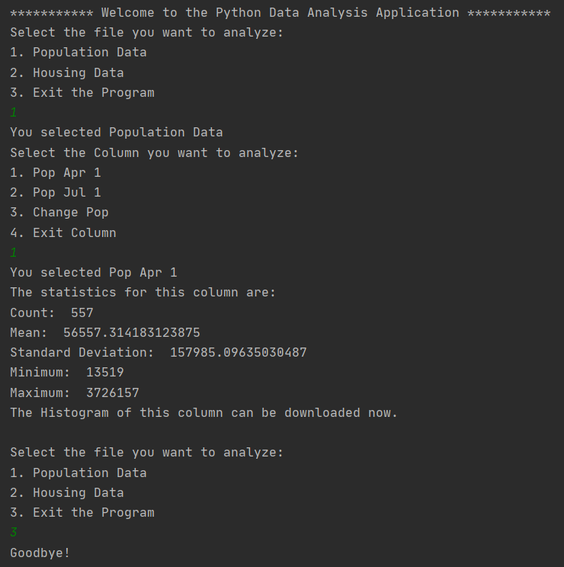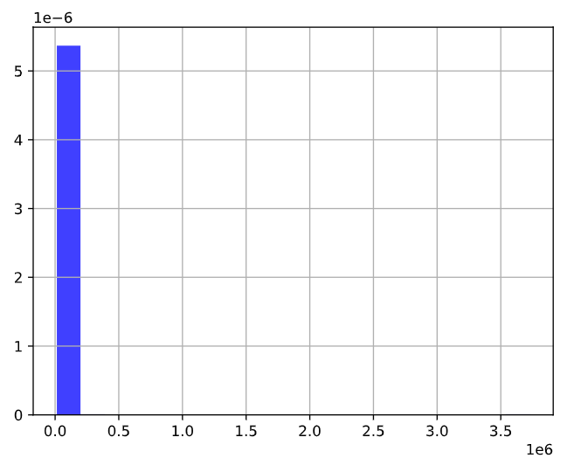

Test 2:

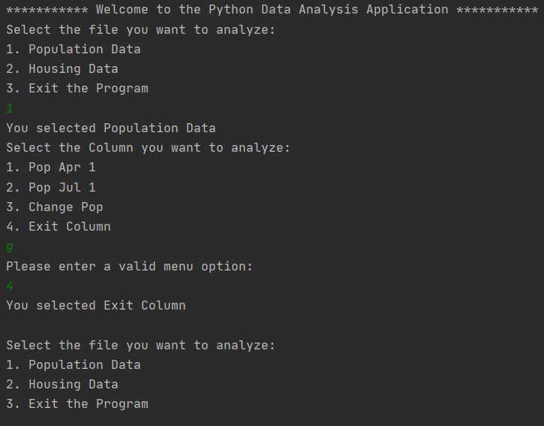

Test 3:

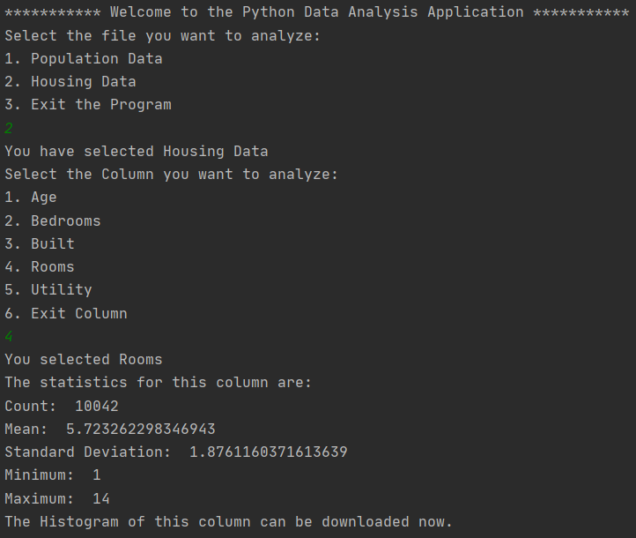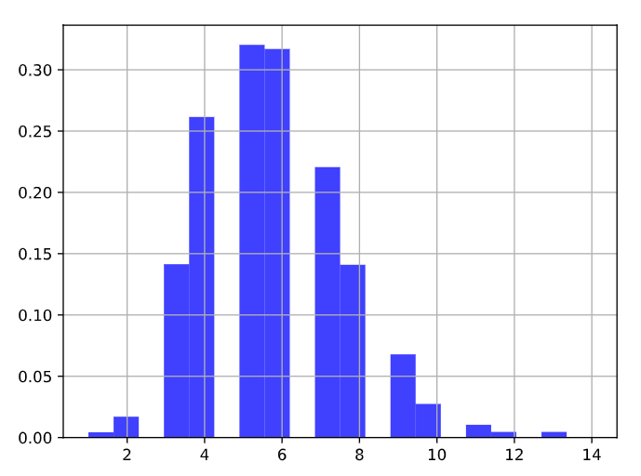

Test 4:

